

Essentials Mathematics

Unit 3

Investigation #1

House costs

**Part 1**

You have decided that the time is right to build your own home.

1. Choose a house plan that suits you. It needs to have at least 3 bedrooms. Do be realistic, a moderately priced first home is what we are looking at. Paste the plan into the document, including the source of the plan.
2. Describe why this plan suits you – what features made you choose it above others?

**Part 2**

We are going to consider the painting required in each of three bedrooms, working from a scale drawing of each bedroom.

1. Choose 3 of the bedrooms from your plan, making sure they are easily identified. Use a separate page of 2mm graph paper for each, draw a scale diagram of the floor plan of the bedroom right in the centre of the page.
2. Describe the process you used to establish the size of your rooms.
3. Explain your reasons for choosing the scale you used on your diagrams.

Ceilings are generally built to a height of 2.4m and doors are usually 2.1m tall.

1. On the graph paper, draw the layout of each of the walls of the room to scale.
2. For each room, describe the choices you made, for example, how big are the windows?
3. In separate working for each bedroom, establish the wall area to be painted, showing all working clearly and explaining any decisions made, for example space not to be painted due to doors. Do not include ceilings, which will be white.

|  |  |
| --- | --- |
| Dulux Wash and Wear | |
| Bunnings prices | |
| Interior, white base | |
|  |  |
| **Size** | **Price** |
| 100mL | $ 6.17 |
| 500mL | $ 28.11 |
| 1L | $ 39.90 |
| 2L | $ 56.33 |
| 4L | $ 73.90 |
| 10L | $ 155.00 |
| 15L | $ 185.00 |

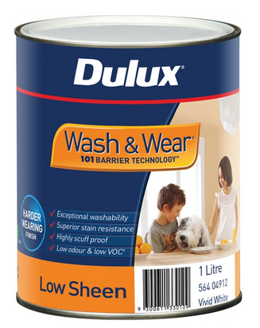

This paint is expected to cover approximately 16 m2 per litre and normally requires two coats for a good finish.

Prices obtained from Bunnings Albany, early in 2014

Image <http://www.bunnings.com.au/dulux-wash-wear-101-1l-low-sheen-white-interior-paint_p1405651>

1. Determine the total wall area to be painted for the three bedrooms, all to be painted the same colour.
2. Calculate the amount of paint required to finish the walls on all three rooms, showing all working.
3. Determine the cost of purchasing the bedroom wall paint using the most economical plan. Explain which tins with be bought and show that it is the cheapest option.

**Part 3**

We are going to brick pave an area near the house. A local contractor will lay bricks for $32 per square metre.

<http://brikmakers.com/pricing.php?type=pavers>

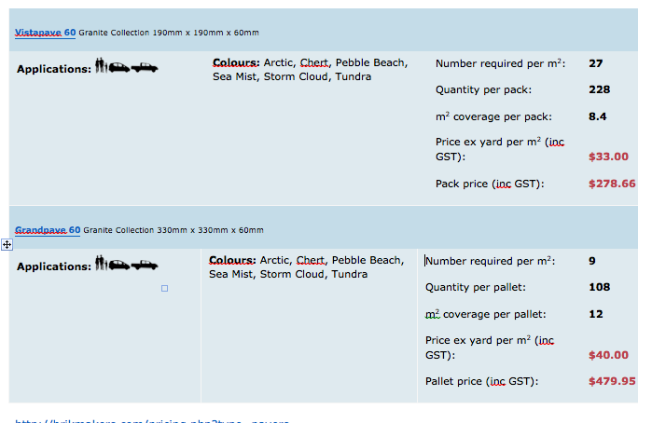

Choose an area around your house to pave. On a copy of the plan, draw in the area to be paved, showing clearly the dimensions of the paving.

1. Justify your decision to pave this area, what makes it suitable, how will it be used?
2. Showing all calculations, determine the area to be paved.
3. Calculate how many packs of bricks need to be purchased for the job – they may only be purchased as whole packs. Explain your reasoning.
4. Determine the cost of the bricks required for the job, showing all working.
5. Calculate the laying costs for this job, you will be charged for a whole square metre even if only part is laid.
6. Determine the entire cost of paving this area, showing all working.

**Part 4**

[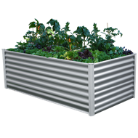](http://www.bunnings.com.au/the-organic-garden-co-200-x-100-x-73cm-zinc-raised-garden-bed_p3321466)You would like to create some vegetable gardens that are easy to manage.

[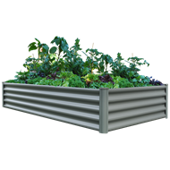](http://www.bunnings.com.au/the-organic-garden-co-200-x-100-x-41cm-grey-raised-garden-bed-_p3321465)

[The Organic Garden Co](http://www.bunnings.com.au/the-organic-garden-co-200-x-100-x-41cm-grey-raised-garden-bed-_p3321465)[The Organic Garden Co](http://www.bunnings.com.au/the-organic-garden-co-200-x-100-x-73cm-zinc-raised-garden-bed_p3321466)

The Organic Garden Co 200 x 100 x 41 cm Grey Raised Garden Bed **$119**

The Organic Garden Co 200 x 100 x 73 cm Zinc Raised Garden Bed **$199**

<http://www.bunnings.com.au/search/products?q=organic%20garden%20co%20raised%20garden%20bed&facets=CategoryIdPath%3D2a021706-07d5-4648-bf26-2ea8fea049df%20%3E%2001f69b03-7098-42c3-b3c2-0a3c184efb7c>

Soil suitable for vegetables and flowers costs $87 per cubic metre to pick up.

1. Describe how many beds you are going to create and decide which size you want. Explain your choice.
2. Determine the cost of the garden beds you are going to use, showing working.
3. Determine the amount of soil you will require to fill all your garden beds, showing the calculations.
4. Calculate the cost of the soil your will need to purchase for the beds, remembering it needs to be bought in whole cubic metres. Explain your result.
5. Calculate the total cost of installing the garden beds at your house, explaining the process you use.
6. Determine the total length of metal sheeting used to construct your gardens, showing all working.

End of Investigation

**Marking Guide**

|  |  |  |  |
| --- | --- | --- | --- |
| ***No*** | ***Item*** | ***Mark*** | ***Mark*** |
| **1** | House plan included  Source (reference) | **2**  **1** |  |
| **2** | Reasons for choice | **3** |  |
| **3** | Floor plan – scale  Neatness  Measurements  Doors, windows | **3**  **3**  **3**  **3** |  |
| **4** | Process for room size | **3** |  |
| **5** | Choice of scale | **2** |  |
| **6** | Wall diagrams – ceiling ht  Neatness  Measurements  Doors, windows | **3**  **3**  **6**  **6** |  |
| **7** | Window sizes | **3** |  |
| **8** | Wall area – working for rect  Missing areas  Subtraction | **3**  **3**  **3** |  |
| **9** | Total paintable area | **3** |  |
| **10** | Total amount paint | **3** |  |
| **11** | Paint cost – feasible  Cost  Compare costs | **1**  **1**  **2** |  |
| **12** | Paving area – feasible  Measurements | **1**  **2** |  |
| **13** | Justify paving area | **3** |  |
| **14** | Area – dimensions  Calculation  Units | **1**  **2**  **1** |  |
| **15** | Brick packs – number  Reasons | **1**  **2** |  |
| **16** | Brick cost | **2** |  |
| **17** | Laying cost | **2** |  |
| **18** | Brick paving total cost | **2** |  |
| **19** | Garden bed choice | **3** |  |
| **20** | Garden bed costs | **2** |  |
| **21** | Amount of soil – dimensions  Calculations  Units | **2**  **2**  **1** |  |
| **22** | Soil cost | **3** |  |
| **23** | Total garden bed cost | **3** |  |
| **24** | Total length | **3** |  |
| **Tot** |  | **101** |  |